**Reinforcement Learning**

**Question 1: Markov Decision Process and Q-Learning**

**3.**

**Markov_Decision_Process.ipynb screenshots**

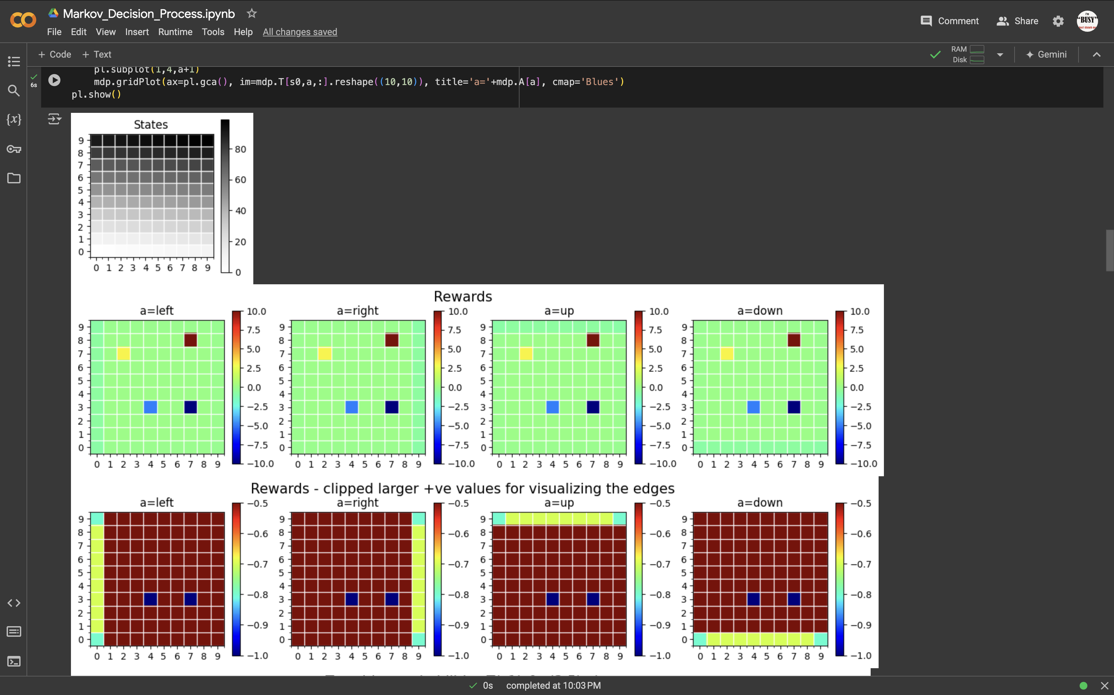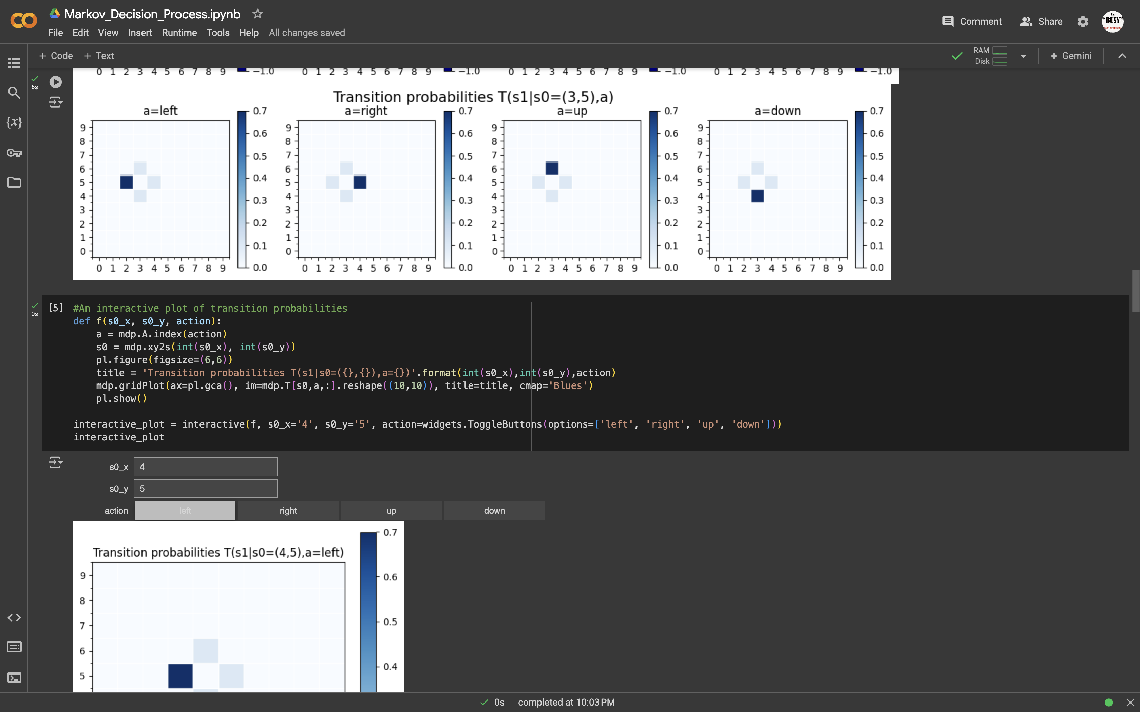

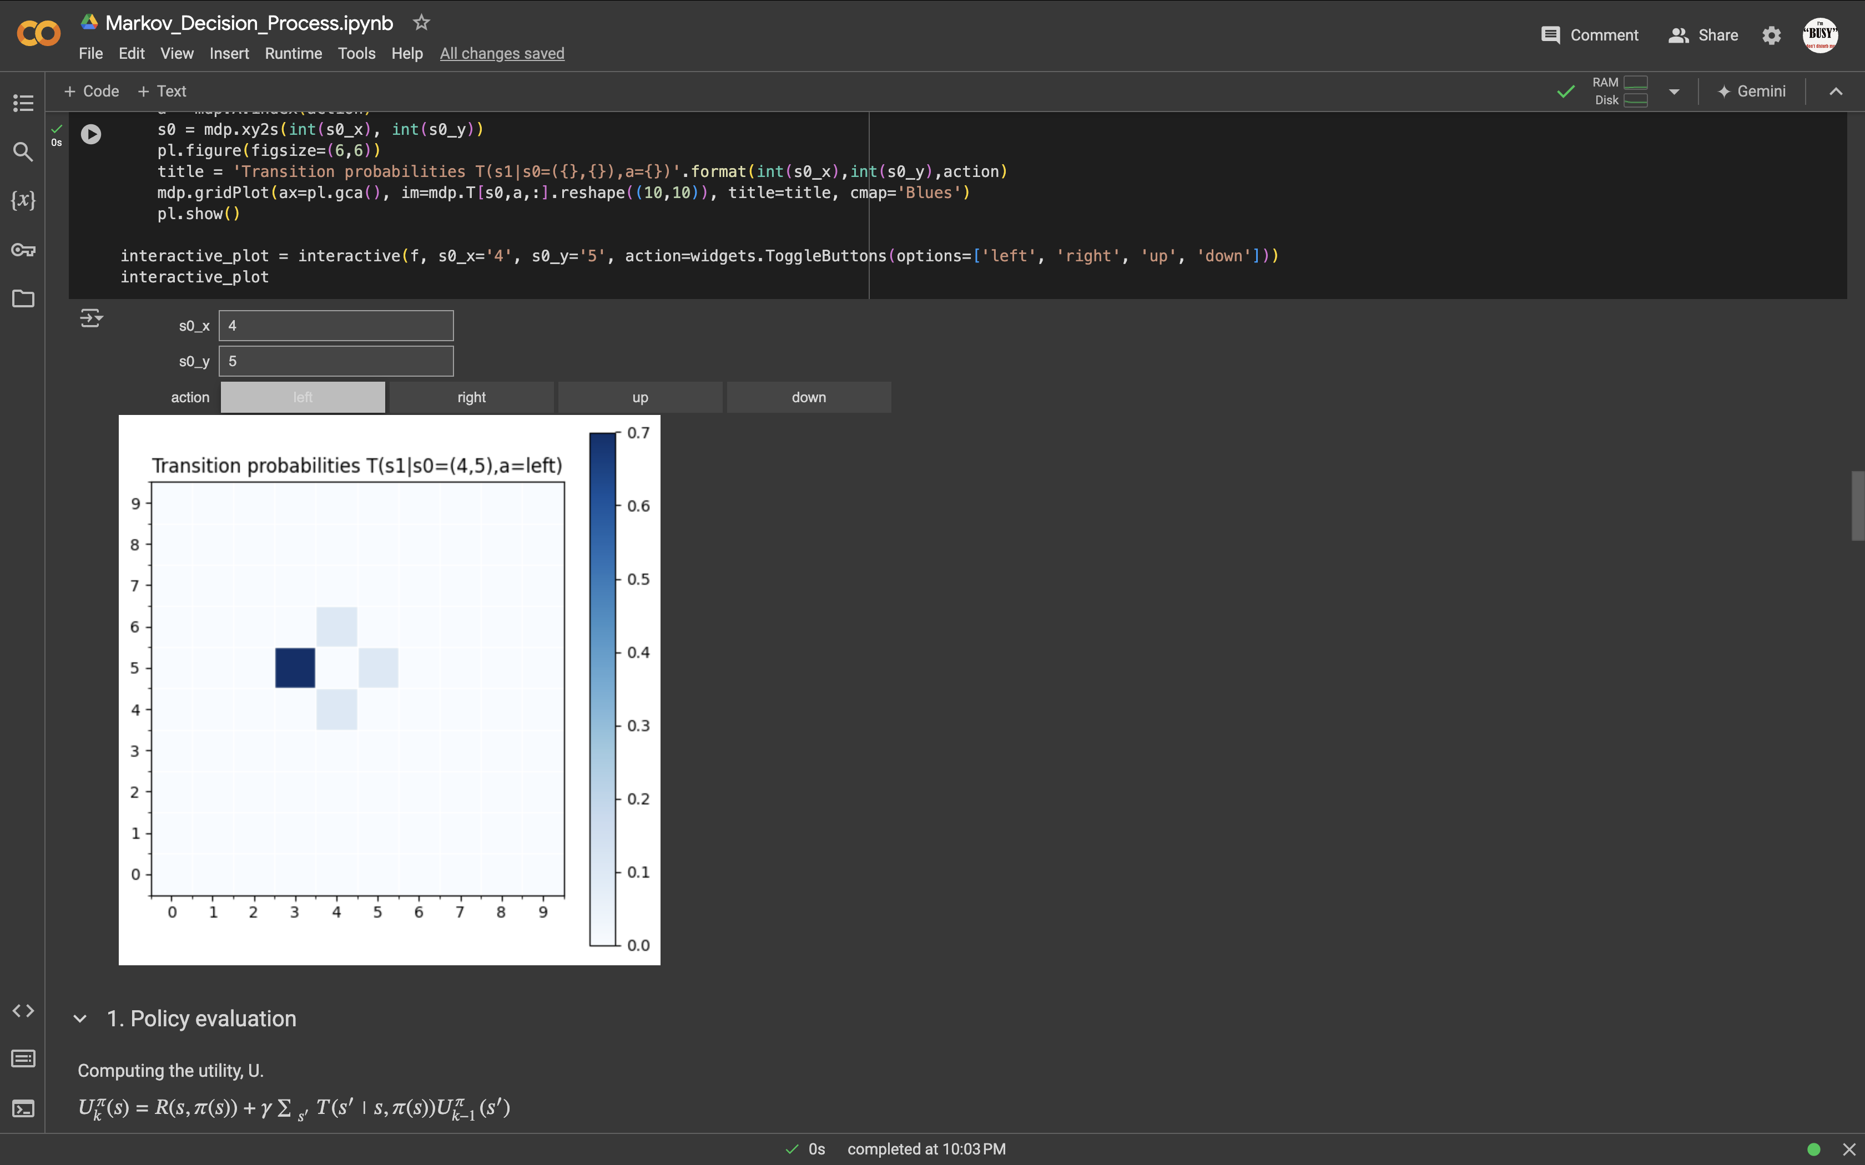

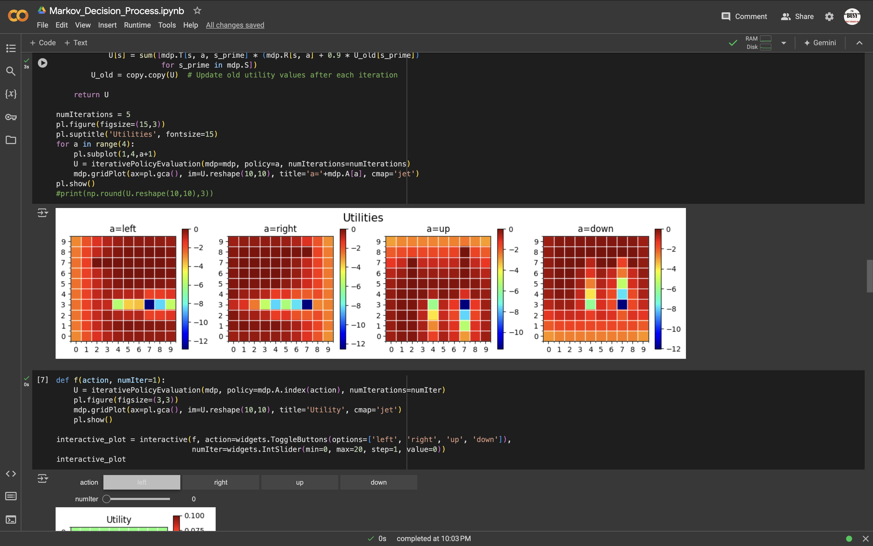

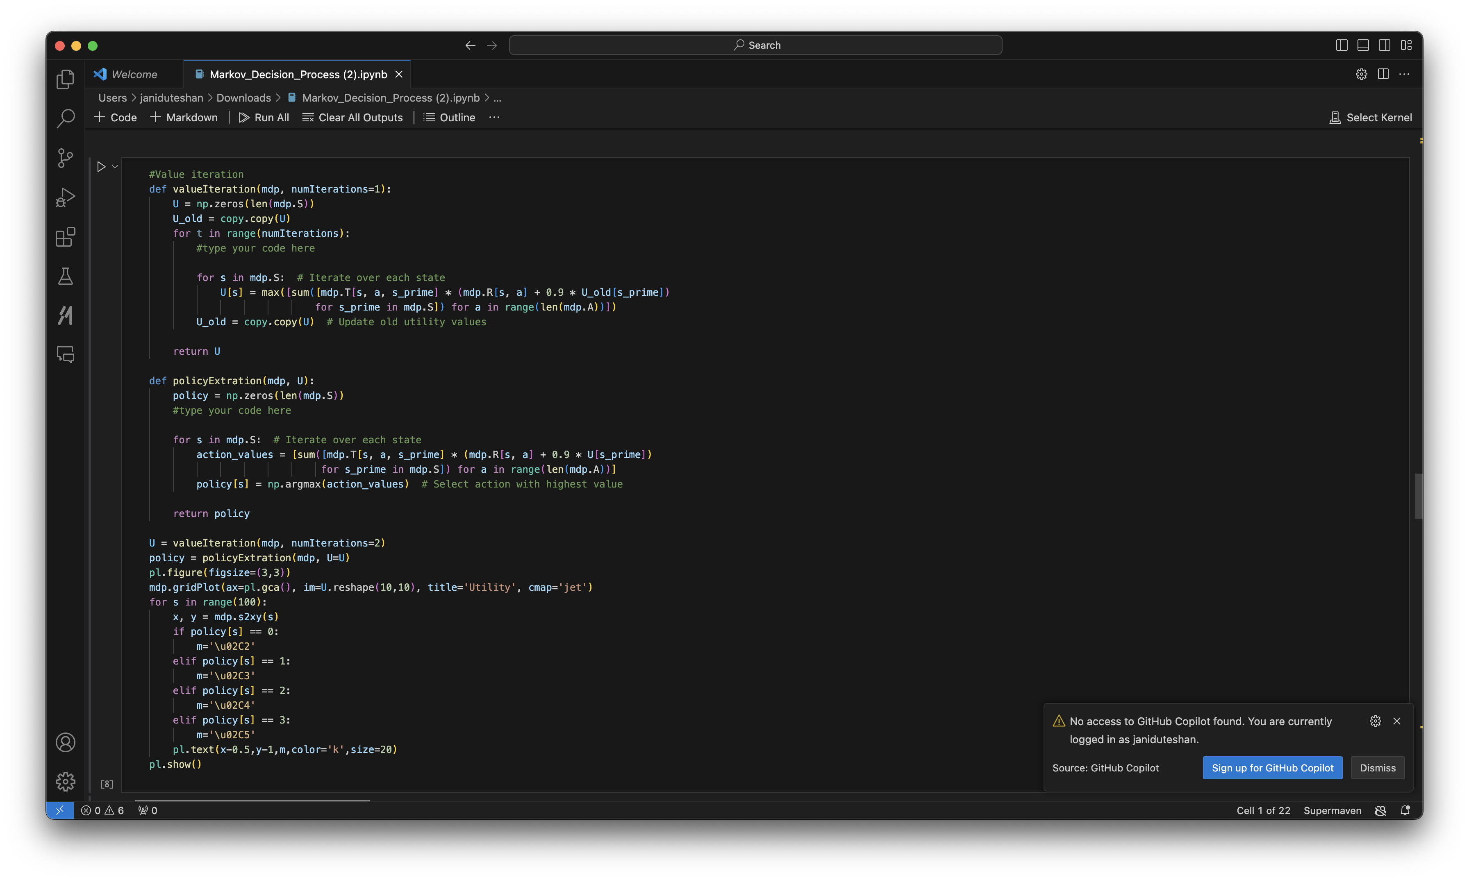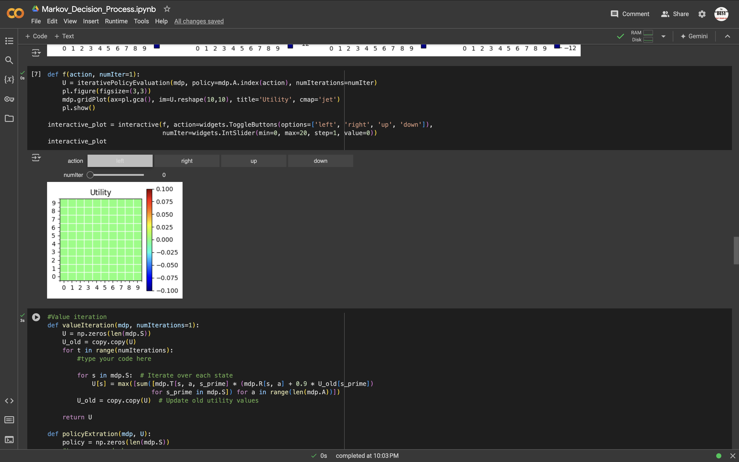

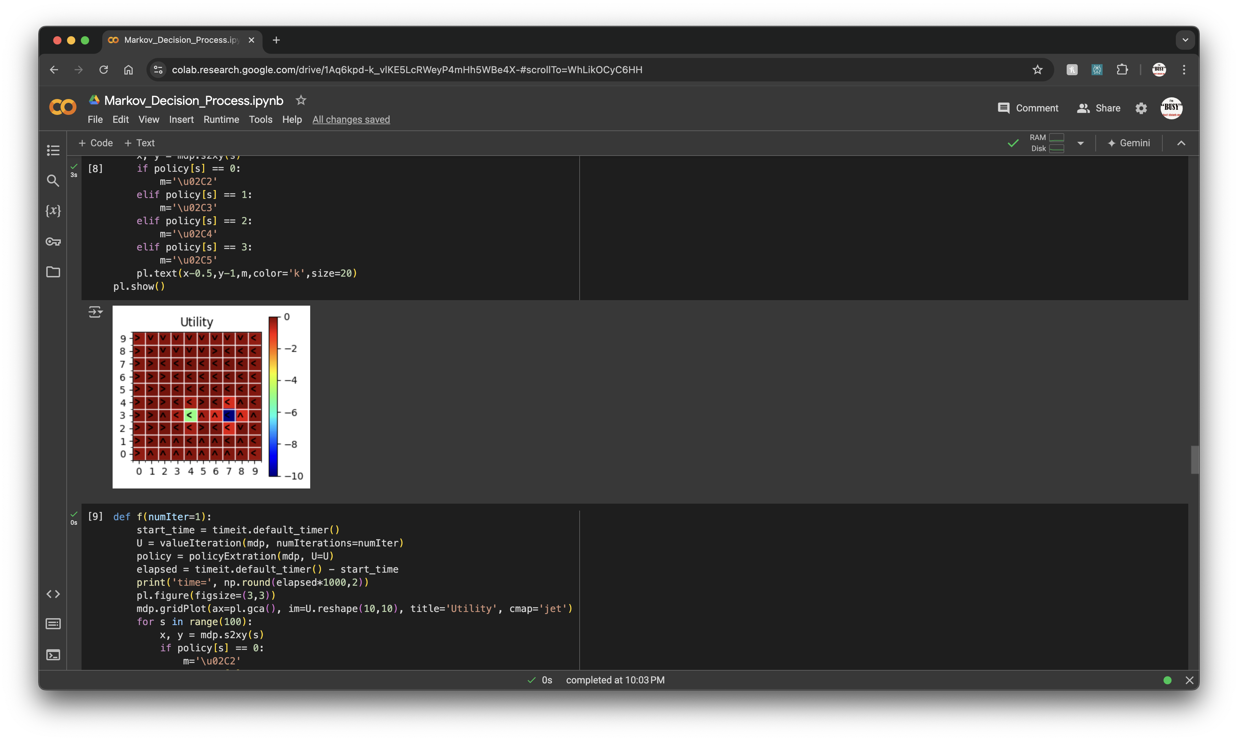

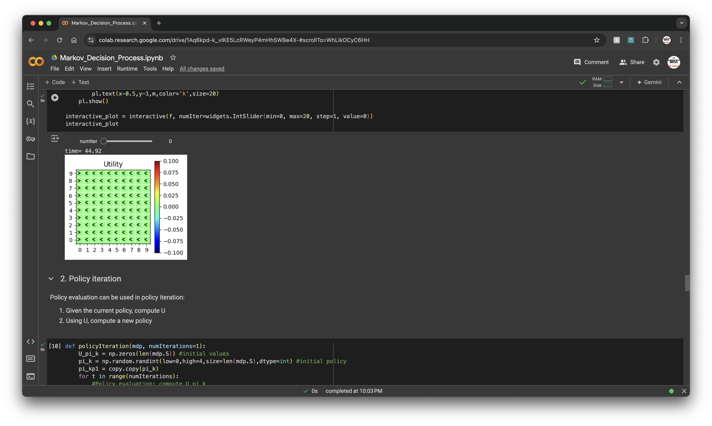

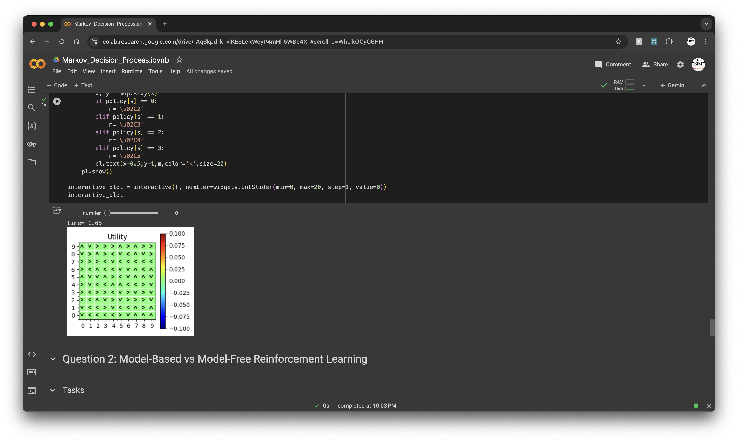

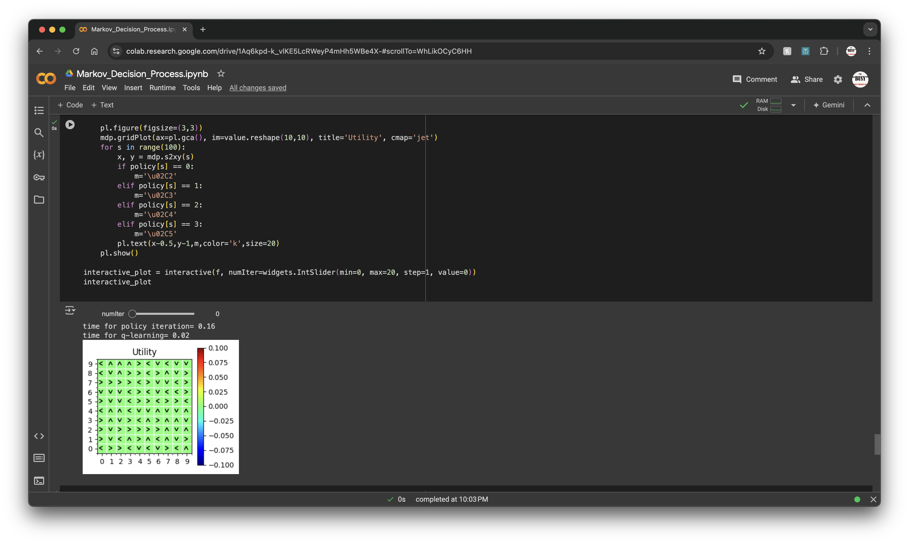

**Gridworld.ipynb**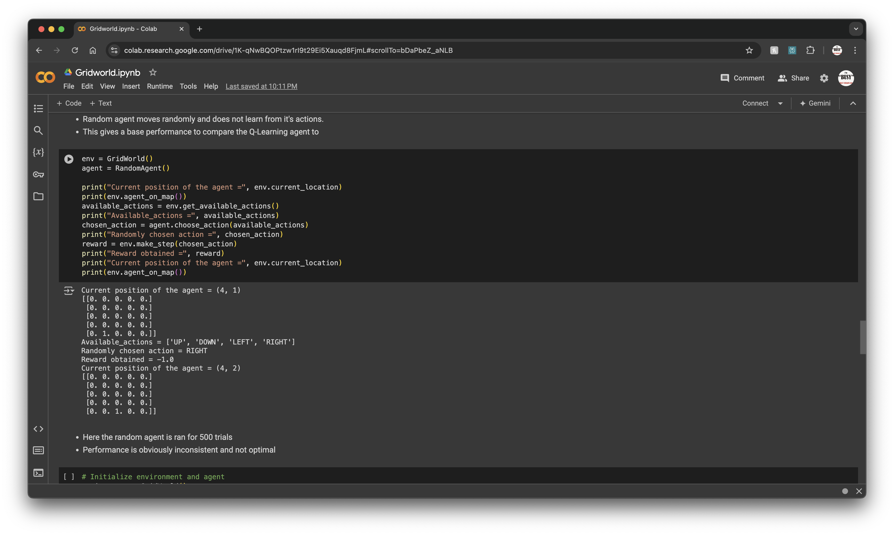

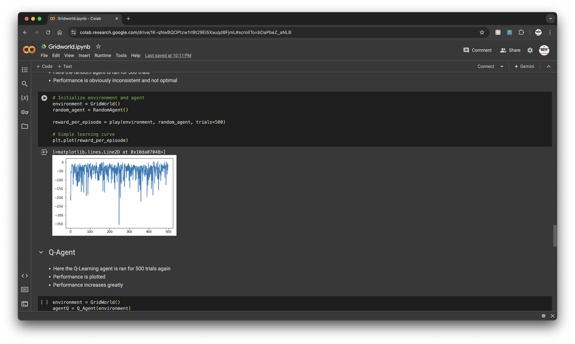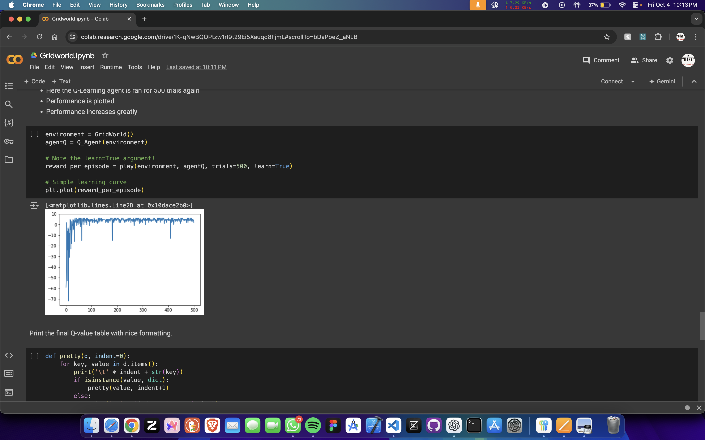

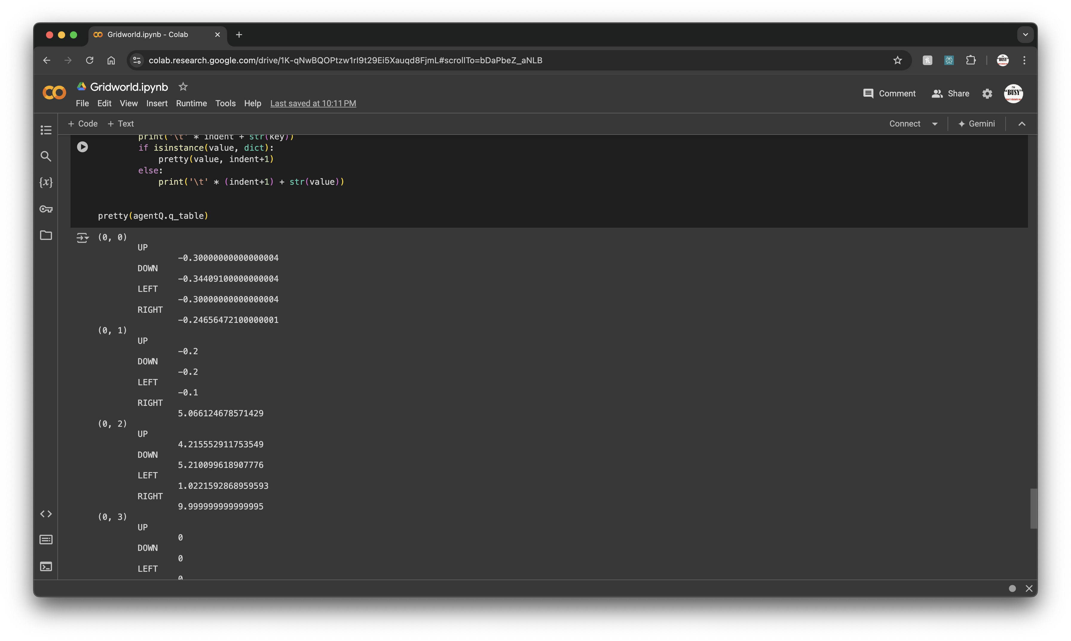

**Question 2: Model-Based vs Model-Free Reinforcement Learning**

**2.**

**Model-Based Algorithms**

**Learns a model of the environment, utilizing planning to optimize decisions.**

**Definition**: These algorithms explicitly construct a model of the environment, capturing its dynamics, including state transitions and rewards.

**How They Work**: They employ this model to simulate future states and assess the consequences of actions, enabling the agent to make informed decisions based on anticipated outcomes.

**Examples**: Value Iteration, Policy Iteration, Dyna-Q.

**Advantages**:

They can be more sample-efficient because they use the model to simulate experiences.

They are also suitable for environments where the dynamics are known or can be effectively learned.

**Disadvantages**:

Building an accurate model can be computationally expensive and complex, particularly in large or continuous spaces.

**Model-Free Algorithms**

## Learns policies directly from experience, relying on trial and error without a model.

These algorithms, unlike others, don’t construct or utilize a model of the environment. Instead, they directly learn from interactions with it.

**Here’s how they work**: They rely on a combination of exploration and exploitation to update the value of states or actions based on the received rewards, without simulating future states.

**Examples include** Q-Learning, SARSA, and REINFORCE.

**Advantages**:

These algorithms are simpler and often easier to implement because they don’t require a model.

They’re effective in environments where the dynamics are unknown or too complex to model.

**Disadvantages**:

However, they’re usually less sample-efficient, as they might need numerous interactions with the environment to acquire optimal policies.

**Question 3: Introduction to Deep Q-Learning (DQN)**

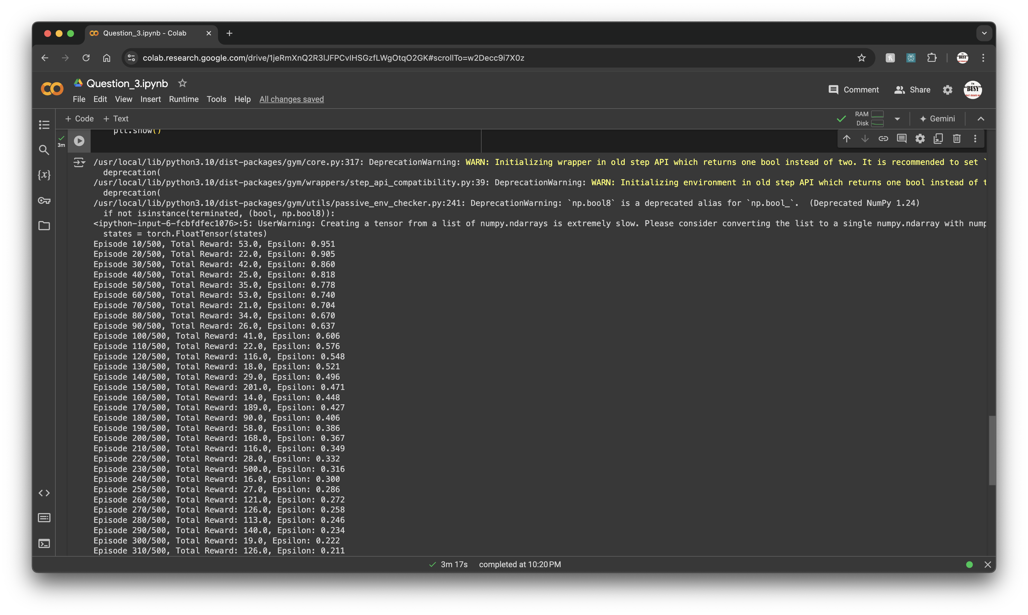

**4.**